CURRICULUM – VITAE

Name: Dr. Neetu Agarwal  (Assistant Professo, Pacific  college of basic and applied  science )  Ph. D ( Mobile Cloud Computing )  MCA (Computer Application)  Other qualification | Home Add: 215, Hiran Magri, Sec. No. 3, Vikas Hospital Road, Udaipur  Email: neetu.agarwal1508gmail.com  Contact no.+919413521464 | 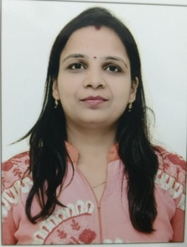

Teaching and Research Experience (in years)

Teaching | Experience: 10 years | P.G.: 10 years | U.G. : 10 years
Research | Experience 2012 to till now | Published papers =12 | Communicated= 01
Seminar  /Conference/  Workshop | Total =12 | International= 4 | National = 8
FDP | Total =01 | International =00 | National =01
Editor/Advisory  /Fellow member  of research  journal | Total=00 | 1.Editor in Chief : Nil
Book Publication/  Chapters | Total=00 | Author Name :- Nil  Book name:- Nil
Guest Lecture/ Invited Speaker | Total =00
Committee/ Activity coordinator / | Total =00 | - Coordinator admission committee  - Coordinator of Workshop /Guest Lecture / Seminar and Conference Committee  - Member of college culture and festival Committee  - Coordinator of Scholarship committee  - Member of IQAC
Other achievements |  | 1. Awarded by IInd prize in Paper Presentation Competition in the VII National Conference  2. Awarded by “Gaargi Devi” Award by government of Rajasthan for securing 79% in Secondary Examinations

Fields of Specialization: Mobile Cloud Computing, Artificial Intelligence

Ph.D.Research Work Topic
Title: The Integrated Challenges and opportunities among cloud services and wireless network (Mobile).
Ph. D .Award :- 06/01/16

