CURRICULUM – VITAE

Name Dr Neetu Shorgar  (Associate Professor, Pacific  college of basic and applied  science )  Ph. D:2007  M.Sc.:2003 | Home Add: 28-kh-16, Ravindra Nagar, Near Ice Factory, Udaipur (Rajasthan)  Email nshorgar@gmail.com  Contact no.+ 9610716595, 9079036225 | 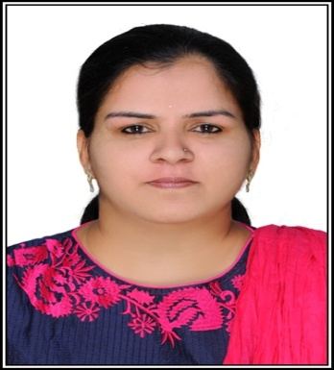

Teaching and Research Experience (in years)

Teaching | Experience: 10 years | P.G.: 07 years | U.G. : 10 years
Research | Experience 2003 to till now = 14 years | Published papers =15 | Communicated= 00
Seminar  /Conference/  Workshop | Total =17 | International= 06 | National = 11
FDP | Total =02 | International =00 | National =02
Editor/Advisory  /Fellow member  of research  journal | Total=00 | 1.Editor in Chief :
Book Publication/  Chapters | Total=01 | Author Name :- Sanyogita Sharma and Neetu Shorgar  Book name:- Sonochemistry: An Emerging Green Technology Apple Academic Press, USA.
Guest Lecture/ Invited Speaker | Total =01 | At JRNU, Udaipur (Rajasthan)
Committee/ Activity coordinator / | Total =03 | - Coordinator of Minority committee  - Coordinator admission committee  - Coordinator of Workshop /Guest Lecture / Seminar and Conference Committee  - Coordinator of Placement Cell Committee  - Member of college culture and festival Committee  - Member of college examination committee
Other achievements
Fields of Specialization: Chemical Kinetics

Ph.D.Research Work Topic "Studies in Kinetics and Mechanism of Oxidative transformation of amino - acids and hydroxyl group containing drugs using Manganese (III) in phosphoric acid-water medium
Tittle:
Ph. D .Award :- 09/06/2007

Research Publications Total Papers: 15

Published Papers: 15

