CURRICULUM – VITAE

Name-- Dr. Paras Tak  (Assistant Professor, Department of Chemistry, Pacific  college of basic and applied  science ) PAHER, University, Udaipur  Ph. D (2010)  (M.Sc. (2005) B.Sc. (2003) | Home Add: 196/14, Ashok Nagar , Udaipur (Raj.) 313001  Email-parastak2011@gmail.com  Contact no.+ 9462566872 | 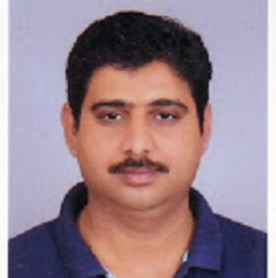

Teaching and Research Experience (in years)

Teaching | Experience: 12 years | P.G.: 7 years | U.G. : 12 years
Research | Experience 12 to till now = 12 years | Published papers =00 | Communicated= 00
Seminar  /Conference/  Workshop | Total =36 | International= 03 | National = 33
FDP | Total =03 | International =00 | National =02
Editor/Advisory | Total=00 | 1.Editor in Chief :
/Fellow member
of research
journal
Book Publication/  Chapters | Total=04 | Author Name :-  - Green Chemistry, Suresh C. Ameta and Rakshit  Ameta ,Apple Academic Press, New Jersey  (USA) 2014.  (2) Microwave Assisted Organic Synthesis A Green  Chemical Approach” Suresh C. Ameta, Pinki B.  Punjabi, Rakshit Ameta and Chetna Ameta,  Apple Academic, Press, New Jersey (USA) 2014.  (3) Solar Energy and Conversion Efficiency” Suresh  C. Ameta and Rakshit Ameta (Eds.)  Taylor & Francis UK (In Press).  Book Name: (1) “Green Chemistry Fundamentals & Applications” Apple Academic Press, New Jersey (USA) 2014.  (2) Microwave Assisted Organic Synthesis A Green  Chemical Approach, Suresh C. Ameta, Pinki B.  Punjabi, Rakshit Ameta and Chetna Ameta (Eds.)  Apple Academic,Press, New Jersey (USA) 2014.
Guest Lecture/ Invited Speaker | Total =00
Committee/ Activity coordinator / | Total =04 | - Coordinator of Minority committee  - Coordinator admission committee  - Coordinator of Workshop /Guest Lecture / Seminar and Conference Committee  - Coordinator of Placement Cell Committee  - Member of college culture and festival Committee  - Member of college examination committee
Other achievements | Awards | - Won 1St Prize in PG Seminar on Sigmatropic  Rearrangemen Reaction in 2005.  - Won 1st Prize in Poster Presentation in National Conference on “Green Techniques”  organized by Mewar University Chittorgarh  (Raj.) July 2014.  - Won 1st Prize in National Conference on “Advances In Chemical, Enviromental and  Biological Sciences” Organized by Govt.  Meera Girls College, Udaipur (Raj.) 2016

Fields of Specialization: Photochemistry, Green Chemistry, Fluoride removal Technique,
Bio-Adsorbent and Food Anti Oxidants,

Ph.D.Research Work Topic- Photochemistry
Tittle: “Use Of Copper Hexacyanoferrate (II) As A Photocatalyst For Treatment of polluted Water”
Ph. D .Award :- 26/02/2010 (Submitted- Feb. 2009 )

Research Publications Total Papers: 21

Published Papers: 17

