CURRICULUM – VITAE

Name: Jatin Suman  (Teaching Assistant, Pacific  college of basic and applied  science )  M.Sc. (Mathematics) | Home Add:  C 23-24, Sidhivinayak Nagar, Arnod Road  Pratapgarh  Email: sumantannu143@gmail.com  Contact no.:  +91-8740878764 | 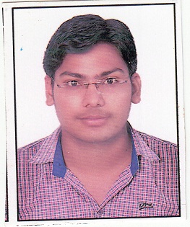

Teaching and Research Experience

Teaching | Experience: 00 years | P.G.: 0 years | U.G. : 0 years
Research | Experience 00 to till now = 00 years | Published papers =00 | Communicated= 00
Seminar  /Conference/  Workshop | Total =02 | International= 01 | National = 01
FDP | Total =01 | International =00 | National =01
Editor/Advisory  /Fellow member  of research  journal | Total=00
Book Publication/  Chapters | Total=00 | Author Name :-  Book name:-
Guest Lecture/ Invited Speaker | Total =00
Committee/ Activity coordinator / |  | - Member of Transportation Committee in various Conferences  - Member of college culture and festival Committee
Other achievements |  | - Winner of State level Debate competition  - Winner of District level Aashu-Bhasan competition  - College Topper (VBRI) in MSc(Mathematics)  - College Topper (VBRI) in BSc(Mathematics)

