CURRICULUM – VITAE

Name: Ms. NeelamNagda  (Teaching associate, Pacific  College of Basic and Applied  Acience )  M.Sc.(Physics)  B.Sc.(PCM) | Home Add: 18,Tulsi Nagar, Bedwas ,Airport Road Udaipur.  Email:nagda.neelam12994@gmail.com  Contact no.+ 8003928157 | 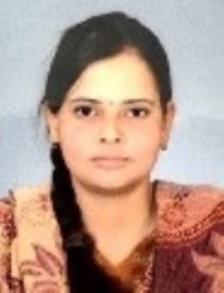

Teaching and Research Experience (in years)

Teaching | Experience: 4 Month Till date | P.G.: 0 years | U.G. : 0 years
Research | Experience 00 to till now = 00 years | Published papers =00 | Communicated= 00
Seminar  /Conference/  Workshop | Total =01 | International= 01 | National = 00
FDP | Total =00 | International =00 | National =00
Editor/Advisory | Total=00 | 1.Editor in Chief :
/Fellow member
of research
journal
Book Publication/  Chapters | Total=00 | Author Name :-  Book name:-
Guest Lecture/ Invited Speaker | Total =00
Committee/ Activity coordinator / | Total =00
Other achievements

